Stage 4 ★★
Mixed Selection 1

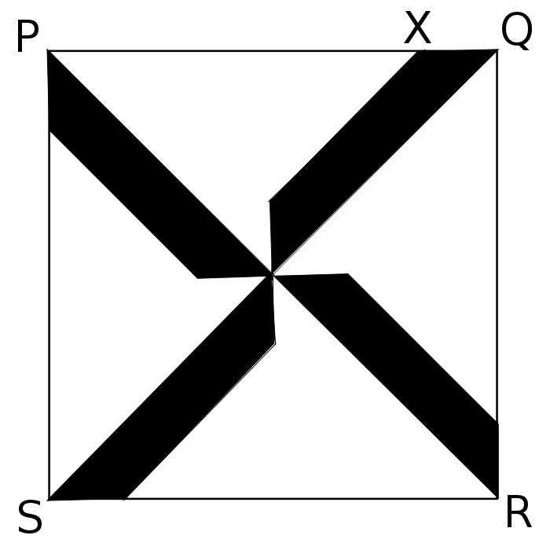
- Quarters
Four congruent isosceles trapeziums are placed so that their longer parallel sides form the diagonals of a square PQRS, as shown. The point X divides PQ in the ratio 3:1.

What fraction of the square is shaded?

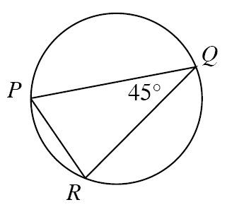

- Angle to chord
$P$, $Q$ and $R$ are points on the circumference of a circle of radius 4cm. $∠PQR=45°$.

What is the length of chord $PR$?

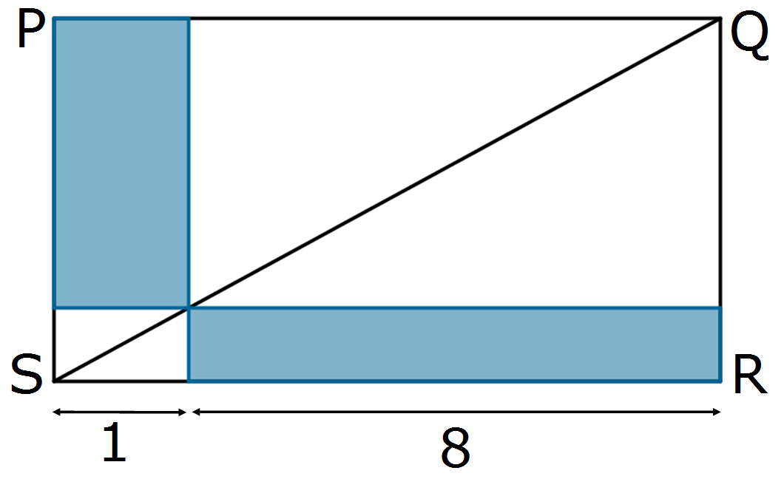

- Diagonal touch
What fraction of rectangle $PQRS$ is shaded?

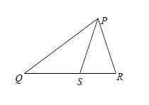
- Isosceles reduction
$PQR$ is a triangle and $S$ is a point on $QR$.
$QP=QR=9$cm and $PR=PS=6$cm.
What is the length of $SR$?

